MITZVAH DAY SUNDAY 19th NOVEMBER 2017
GOODS FOR GOOD

We will be collecting school stationery for the 50 refugee camps in Kurdistan & Syria (where we regularly send clothing, shoes, blankets, and medicines, too).
The reason why the ask is small, (and only for stationery listed below) is that our premises and capacity is very small and we can’t absorb large quantities at one time.
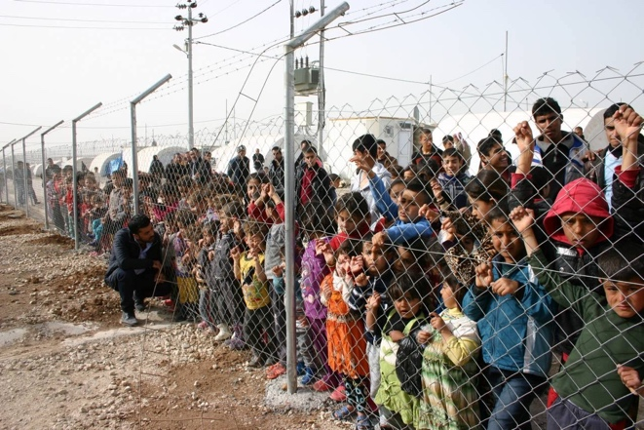
This is what we are asking for (donated stationery should be new, and can be given from goods already found at home by children):
- Felt tips
- Crayons (pencils & wax)
- Drawing pencils
- Drawing & colouring books
- Arts and crafts materials (new packets only)
- Erasers & rulers
- Markers and highlighters
- Exercise books and paper

Children in the refugee camps have little to play with apart from the mud and stones underfoot. They have lost everything. Thousands are orphans and have witnessed or are victims of terrible atrocities. They have lost their possessions, their loved ones. We deliver hope and dignity to them.
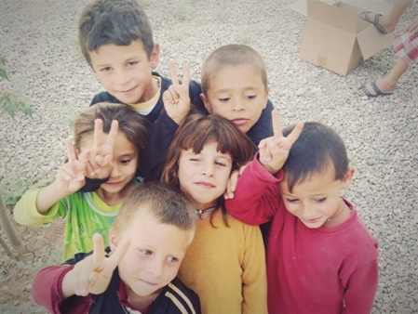
Activity!
Send greetings from your community to the refugees!
- We want you to design a card for the refugee
children receiving your stationery.
- It should include a picture of a Goods For Good
truck delivering goods.
- Write a message from you to your new friend.
- We will send your card with a box of stationery

You may like to see the clip of film sent to us by our charity partners on the ground Bring Hope. https://drive.google.com/open?id=0B0OfeIMZYblnUko0Q1ZCb2R1cEE
Our own trustee, Max Veenstra, is also a trustee of the charity Bring Hope and therefore we are affiliated and working closely together.

Please note: Project participants are requested to deliver or send the stationery to our warehouse between 12 p.m. -3 p.m. on Sunday 19th November, or by appointment after this date. The address where stationery can be sent into, or where volunteers from the community can bring the goods to.
GOODS FOR GOOD
REAR OF UNIT 1a
BOREHAMWOOD SHOPPING PARK
WD6 4PR
(Tel: Mia 07785800500)

